Getting Started with NI LabWindows/CVI

George Netscher

Qiyu Peng

Version 1.0

Contents

1. Overview 2

2. Installation 2

3. How to learn LabWindows 5

1. Overview

This document shows how to install LabWindows and points out what resources we have found to be most useful in learning LabWindows. If you are already familiar with ANSI C, LabWindows will be very easy to learn. If you follow the exercises provided, it will take roughly one day to reach the level of proficiency needed to begin development for the OpenPET project.

# Installation

If you have access to an NI license for LabVIEW or other related projects, you may already have access to LabWindows. If not, the 30-day free trial version can be downloaded from the National Instruments website at <http://www.ni.com/lwcvi/download/>. A full purchase can be made at <http://www.ni.com/lwcvi/buy/>.

Note that the LabWindows software is only available in Windows and cannot be used directly from a Mac or Linux platform at this time.

If you would like to install the free-trial version, click on the link above and follow the instructions given below.

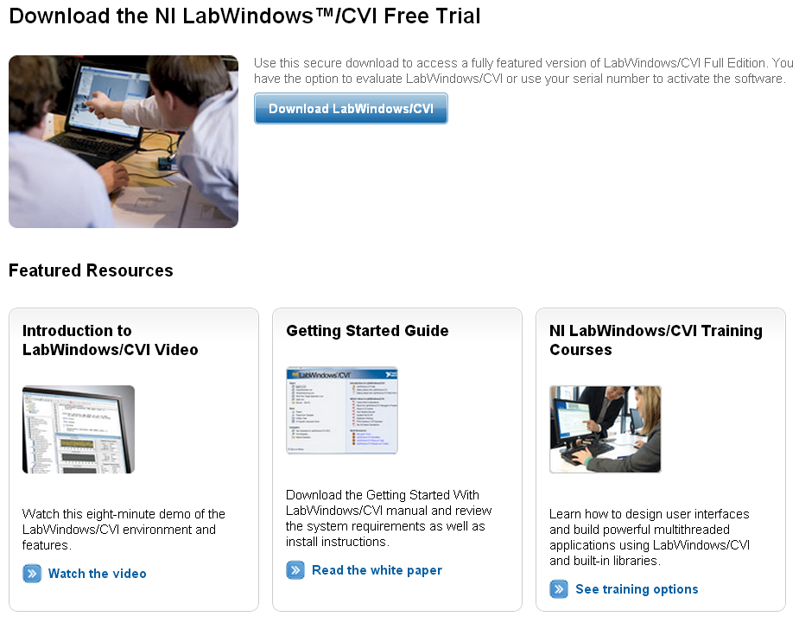

Downloading the free trial version will require creating an NI account.

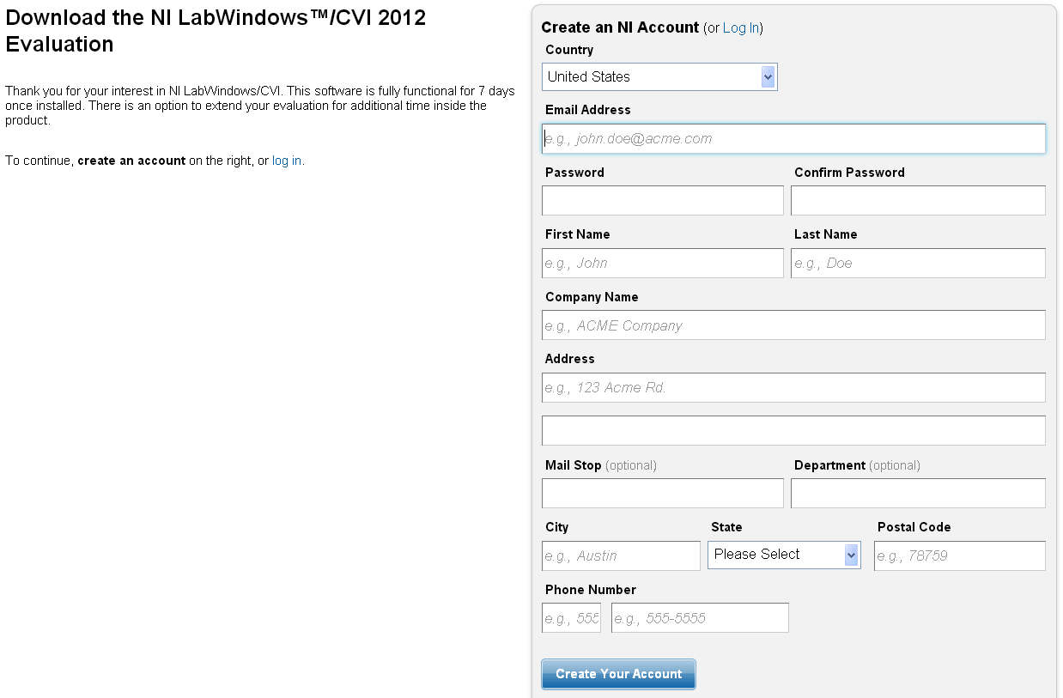

Once you have created an account, you will be able to download the LabWindows software.

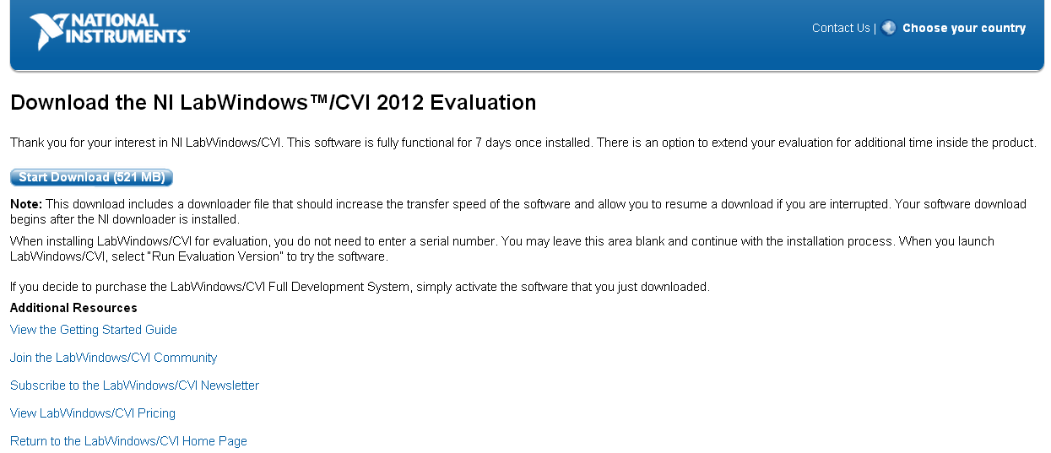

Download and run the executable. Follow the on-screen instructions to complete installation.

# How to learn LabWindows

Upon launching LabWindows for the first time, you should see a screen similar to the one below.

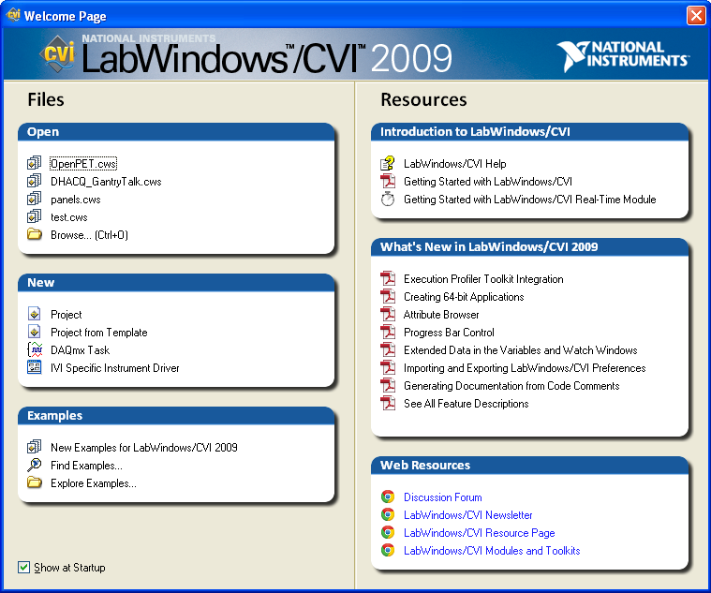

Click on the “Getting Started with LabWindows/CVI” pdf. For your convenience, this document has also been included in the OpenPET “Getting Started” folder on Github <https://github.com/openpet-developer/HostPC/tree/master/Getting%20Started>.

We have found this guide to be very useful. In particular, working through the interactive content and completing the exercises provided at the end will help you to reach the level of proficiency necessary to contribute to the OpenPET project. Other tutorials are available online, but we have found this document alone provides all the information necessary for OpenPET development.

Good luck and happy coding!